Battery charging & discharging simulation

* Models li-ion battery charging / discharging behavior
* Inputs: capacity , current , voltage
* Outputs: SOC(state of charge),efficiency
* Applications: EV battery management systems

Source code:

import numpy as np

import matplotlib.pyplot as plt

class LiIonBattery:

    def __init__(self, capacity_ah, nominal_voltage):

        self.capacity_ah = capacity_ah         # Battery capacity in Ah

        self.nominal_voltage = nominal_voltage # Nominal voltage in V

        self.soc = 1.0                         # Initial SOC (100%)

        self.energy_capacity_wh = capacity_ah * nominal_voltage

        self.energy_stored_wh = self.energy_capacity_wh * self.soc

        self.efficiency_charge = 0.95          # Typical charge efficiency

        self.efficiency_discharge = 0.95       # Typical discharge efficiency

    def update(self, current_a, voltage_v, dt_sec):

        power_w = voltage_v * current_a

        energy_delta_wh = power_w * dt_sec / 3600.0  # Convert W*s to Wh

        # Adjust for efficiency

        if current_a < 0:  # charging

            energy_delta_wh *= self.efficiency_charge

        else:  # discharging

            energy_delta_wh /= self.efficiency_discharge

        self.energy_stored_wh -= energy_delta_wh

        # Limit energy stored within 0 and capacity

        self.energy_stored_wh = np.clip(self.energy_stored_wh, 0, self.energy_capacity_wh)

        self.soc = self.energy_stored_wh / self.energy_capacity_wh

    def get_efficiency(self):

        # Simplified average efficiency

        return (self.efficiency_charge + self.efficiency_discharge) / 2

# Example usage

def simulate_battery():

    capacity_ah = 50        # 50 Ah battery

    nominal_voltage = 400   # 400 V battery pack

    battery = LiIonBattery(capacity_ah, nominal_voltage)

    dt = 1  # 1 second timestep

    time_total = 3600      # simulate 1 hour

    currents = np.zeros(time_total)

    voltages = np.ones(time_total) * nominal_voltage

    currents[:1800] = 10.0

    currents[1800:] = -5.0

    soc_history = []

    for t in range(time_total):

        battery.update(currents[t], voltages[t], dt)

        soc_history.append(battery.soc)

    plt.plot(np.arange(time_total)/60, soc_history)

    plt.xlabel("Time (minutes)")

    plt.ylabel("State of Charge (SOC)")

    plt.title("Li-ion Battery SOC during Charge/Discharge Cycle")

    plt.grid(True)

    plt.show()

    print(f"Final SOC after 1 hour: {battery.soc*100:.2f}%")

    print(f"Battery efficiency estimate: {battery.get_efficiency()*100:.2f}%")

if __name__ == "__main__":

    simulate_battery()

output:

Final SOC after 1 hour: 94.22%

Battery efficiency estimate: 95.00%

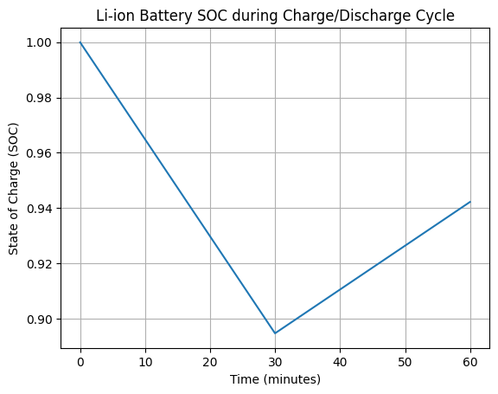

Conclusion:

This Python model simulates a Li-ion battery’s state of charge (SOC) based on input current, voltage, and battery capacity. The model:

* Accounts for **charging and discharging efficiencies** (typical ~95%)
* Updates SOC dynamically over time steps, reflecting real usage cycles
* Provides key metrics such as SOC and overall efficiency useful for **EV battery management systems (BMS)**
* Can be extended to include temperature effects, aging, voltage SOC curves, or more sophisticated control logic